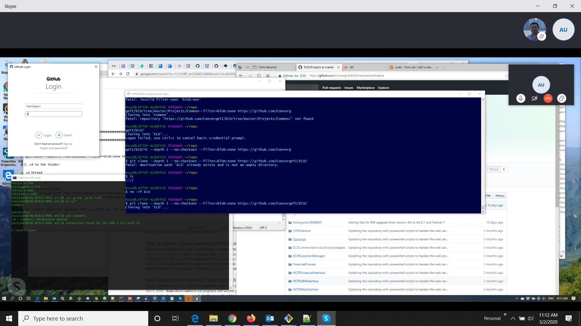

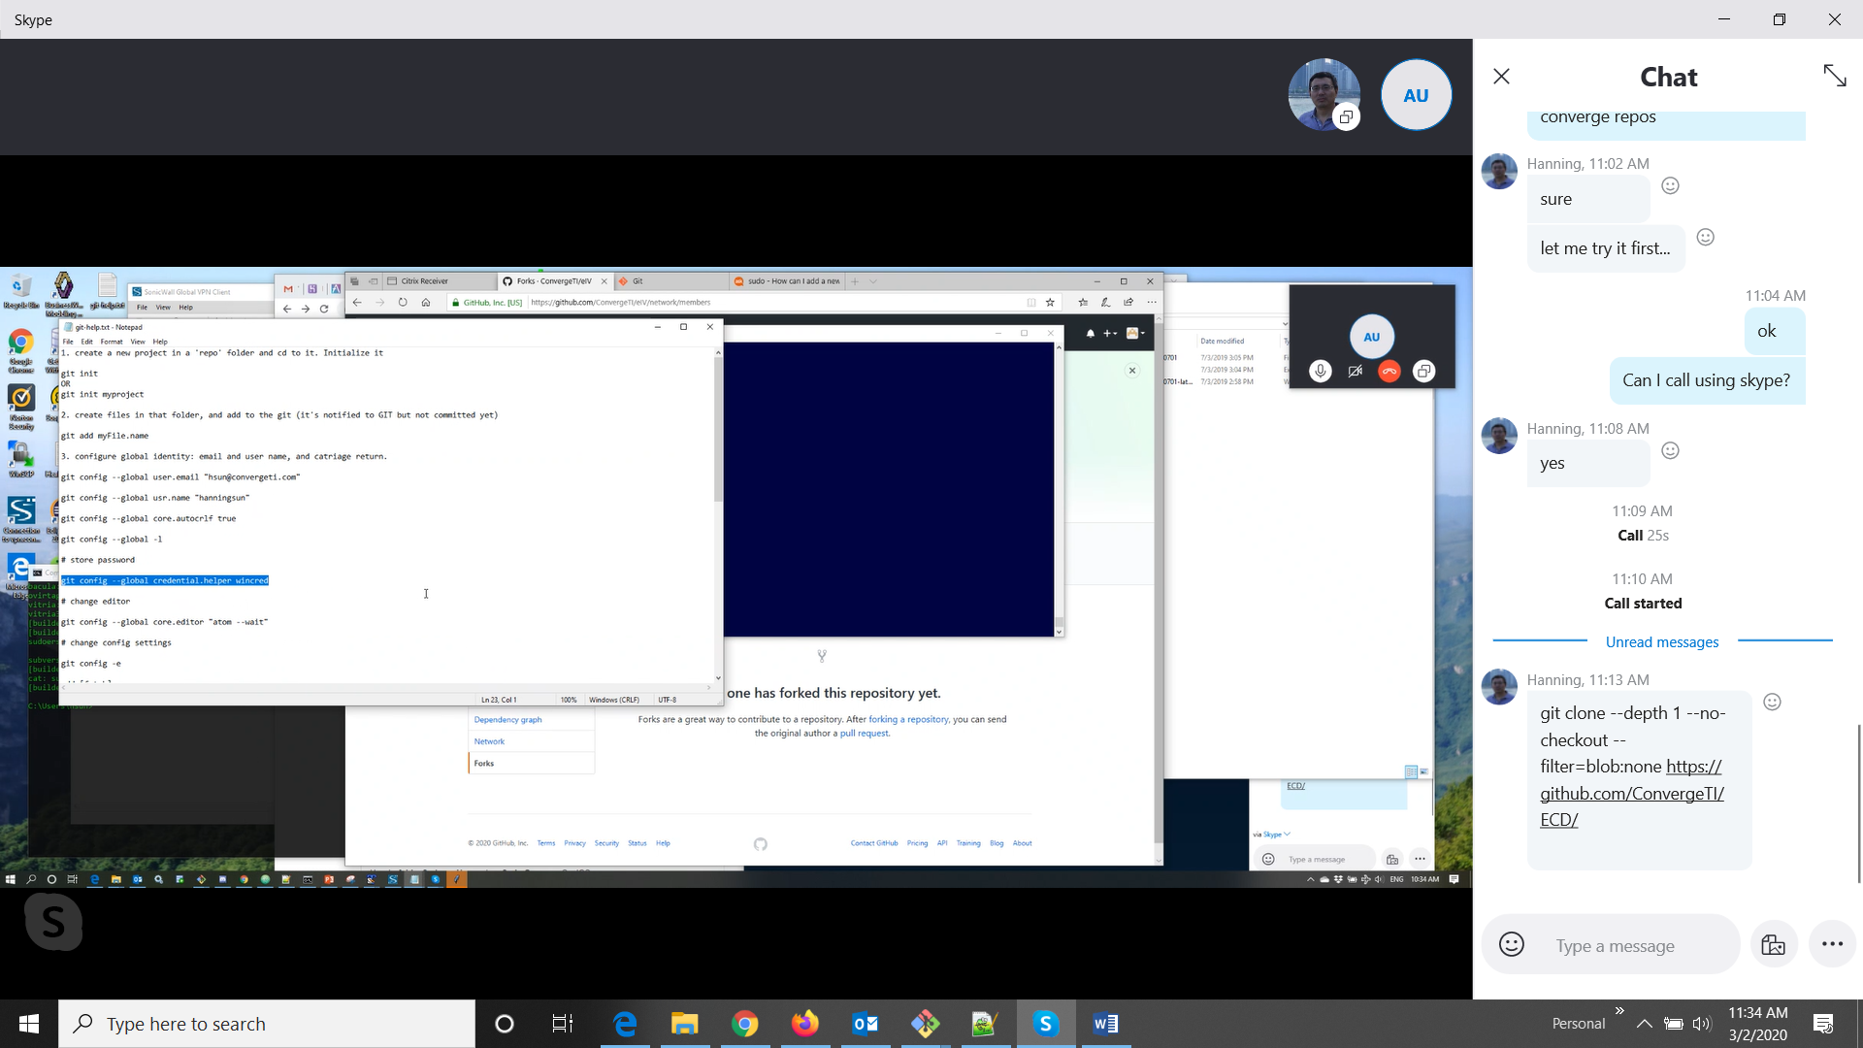

**Important Git concepts**

**=========================**

Here are the basic terms you should familiarize yourself with before embarking on your journey.

**Repository / Repo :**

This is the project's source code that resides on github.com's servers. You cannot modify the contents of this repository directly unless you were the one who created it in the first place.

**Fork** : Forking a project will create a copy of the original repository that you can modify as you please. Forked projects will appear in your own github.com account.

**Cloning** : this will clone an online repository to your hard drive so you may begin working on your modifications. This local copy is called your local repository.

**Branch** : A branch is a different version of the same project. In the case of T2DMIT, you will see 2 branches : the master branch and the development branch.

Remote : A remote is simply an alias pointing to an online repository. It is much easier to work with such aliases than typing in the complete URL of online repositories every single time.

Staging Area : Whenever you want to update your online repository (the one appearing in your github.com account), you first need to add your changes to your staging area. Modifying files locally will not automatically update your staging area's contents.

Important Git commands

Fetch : git fetch will download the current state (containing updated and newly created branches) of an online repository without modifying your local repository. It places its results in .git/FETCH_HEAD.

Merge : git merge will merge the modifications of another branch into the current working branch.

Pull : git pull is actually a combination of git fetch and git merge. It fetches the information from an online repository's branch and merges it with your local copy.

Add : Whenever you modify a file in your local repository or create a new file, that file will appear as unstaged. Calling git add allows you to specify files to be added to your staging area.

Commit : A commit records a snapshot of your staging area, making it ready to be pushed to an online repository.

Push : git push will take all of your locally committed changes and upload them to a remote repository's branch.